PROJECT DOCUMENTATION
Construction Intelligence Hub
A Centralized Platform for Construction Project Management

Milestone 1 Report
Frontend User Interface Development using Python and Streamlit

Submitted by
PRIYADHARSHINI S

COMPUTER SCIENCE AND ENGINEERING
PANIMALAR ENGINEERING COLLEGE
FINAL YEAR

CERTIFICATE
This is to certify that the project titled “Construction Intelligence Hub” has been successfully carried out by PRIYADHARSHINI S, as part of the requirements for COMPUTER SCIENCE AND ENGINEERING in PANIMALAR ENGINEERING COLLEGE during the academic year FINAL YEAR under the guidance and supervision of the undersigned.

This report is a record of the work carried out by the student(s) for Milestone 1 of the project and is submitted in partial fulfilment of the requirements of the course.
Date: ___________________
Place: ___________________

Signature of Project Guide
[Guide Name & Designation]

ACKNOWLEDGEMENT
We would like to express our sincere gratitude to our project guide, [Guide Name], for the valuable guidance, encouragement, and support extended throughout the development of this project.
We are also thankful to the Department of COMPUTER SCIENCE AND ENGINNERING in PANIMALAR ENGINEERING COLLEGE for providing the necessary resources and environment to carry out this work.
Finally, we extend our heartfelt thanks to our family and friends for their constant support and motivation throughout this project.

CONSTRUCTION INTELLIGENCE HUB

Abstract
Construction Intelligence Hub is a centralized platform designed to streamline the management of construction projects. The application addresses common challenges faced in the construction industry such as manual record keeping, fragmented information, and poor communication between project stakeholders. Milestone 1 of this project focuses on building the frontend user interface using Python and Streamlit, providing an intuitive dashboard for project registration, progress tracking, material management, and safety compliance. Future milestones will extend the system with database connectivity, analytics, and AI-based decision support.

1. Introduction
Construction projects are inherently complex, involving multiple stakeholders, resources, schedules, and safety requirements that must be coordinated effectively. The Construction Intelligence Hub project aims to provide a centralized platform for managing construction projects, tracking progress, monitoring resources, and improving communication among project teams.
In Milestone 1, the frontend user interface of the application has been developed using Python and Streamlit, which allows for rapid development of interactive, data-driven web applications. This milestone lays the foundation for a fully functional project management system that will be enhanced with backend and analytical capabilities in subsequent milestones.

2. Problem Statement
Construction projects often face several recurring challenges that reduce efficiency and increase costs, including:
- Manual record management leading to errors and delays
- Difficulty tracking project progress in real time
- Material wastage due to lack of visibility into resource availability
- Lack of a centralized source of project information
- Poor communication between teams and stakeholders
The Construction Intelligence Hub aims to solve these problems by bringing all relevant project information together in a single, easy-to-use dashboard

3. Objectives
The key objectives of this project are:
- Manage construction project information in a structured manner
- Monitor project progress through an intuitive interface
- Manage workforce details for each project
- Track material availability and requirements
- Improve overall project planning and coordination
- Provide a simple and user-friendly interface for all stakeholders

4. Scope
The scope of Milestone 1 is limited to the design and development of a functional frontend interface that demonstrates the core features of the platform using sample data. This includes project registration, progress tracking, material selection, a safety checklist, and site updates. Database integration, user authentication, analytics, and AI-driven features are outside the scope of this milestone and are planned for future development phases.

5. System Architecture
The current architecture (Milestone 1) consists of a single-tier Streamlit frontend application that collects user input through forms and displays the submitted information back to the user. Database integration is planned for later milestones.
User
↓
Construction Intelligence Hub
(Streamlit Frontend UI)
↓
User Inputs (Forms)
↓
Display Submitted Information
(Database integration in later milestones)

6. Technologies Used
Technology | Purpose
Python | Programming Language
Streamlit | Frontend UI Development
IDLE Python | Code Editor

7. Proposed System
The proposed Construction Intelligence Hub is envisioned as a comprehensive, data-driven platform that goes beyond the current milestone's frontend prototype. The system will provide role-based access for project managers, workers, and administrators, and will integrate real-time data such as weather and material deliveries to support proactive project management.

8. UI Screenshots
This section showcases screenshots captured directly from the running Construction Intelligence Hub application (localhost:8501), covering the Dashboard, Project Management, Cost Prediction, Delay Risk, Safety Analytics, Vision Scanner, AI Assistant, AI Reports, and About pages.

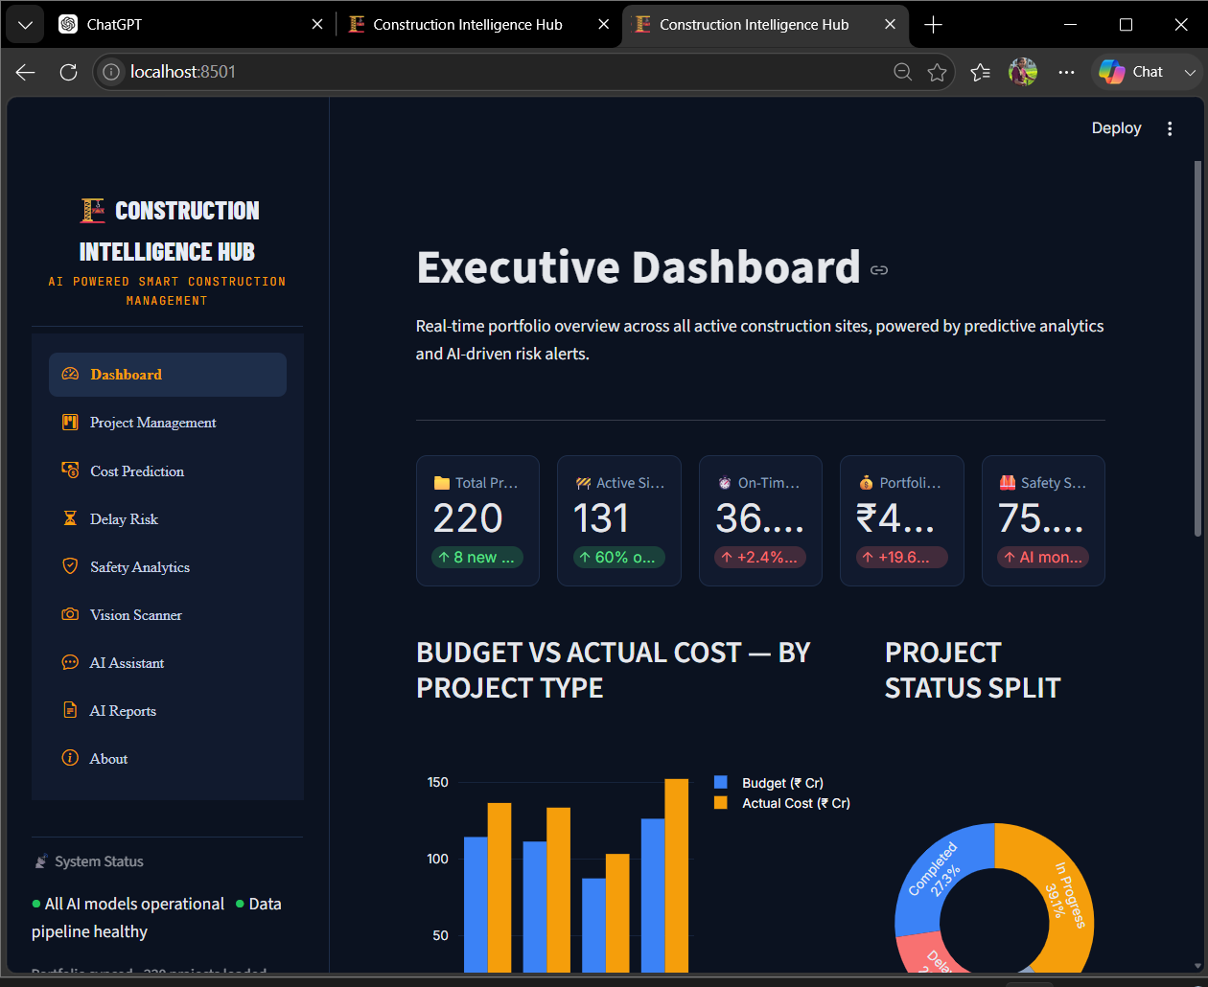

Figure 8.1 – Executive Dashboard

Definition: The Dashboard is the landing screen of the application. It gives a real-time, portfolio-wide summary of all active construction sites, combining key metric cards with charts.
Explanation: Five metric cards summarize the portfolio: Total Projects (220), Active Sites (131), On-Time percentage, Portfolio Value, and a Safety Score. Below them, a grouped bar chart compares planned Budget against Actual Cost for each project type (Commercial, Industrial, Infrastructure, Residential), and a donut chart shows the project status split (Completed, In Progress, Delayed, On Hold, Planning).

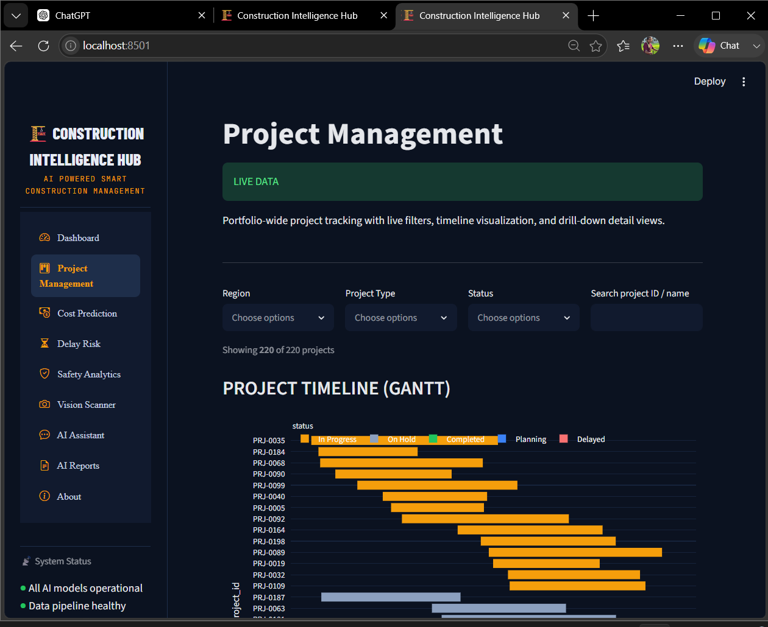

Figure 8.2 – Project Management

Definition: The Project Management page provides project tracking with live filters and a timeline visualization.
Explanation: Filter controls for Region, Project Type, Status, and a search box let the user narrow down the 220-project portfolio. Below the filters, a Gantt-style timeline chart plots each project's planned duration, colour-coded by status, followed by a searchable project registry table listing each project's ID, name, type, region, contractor, and status.
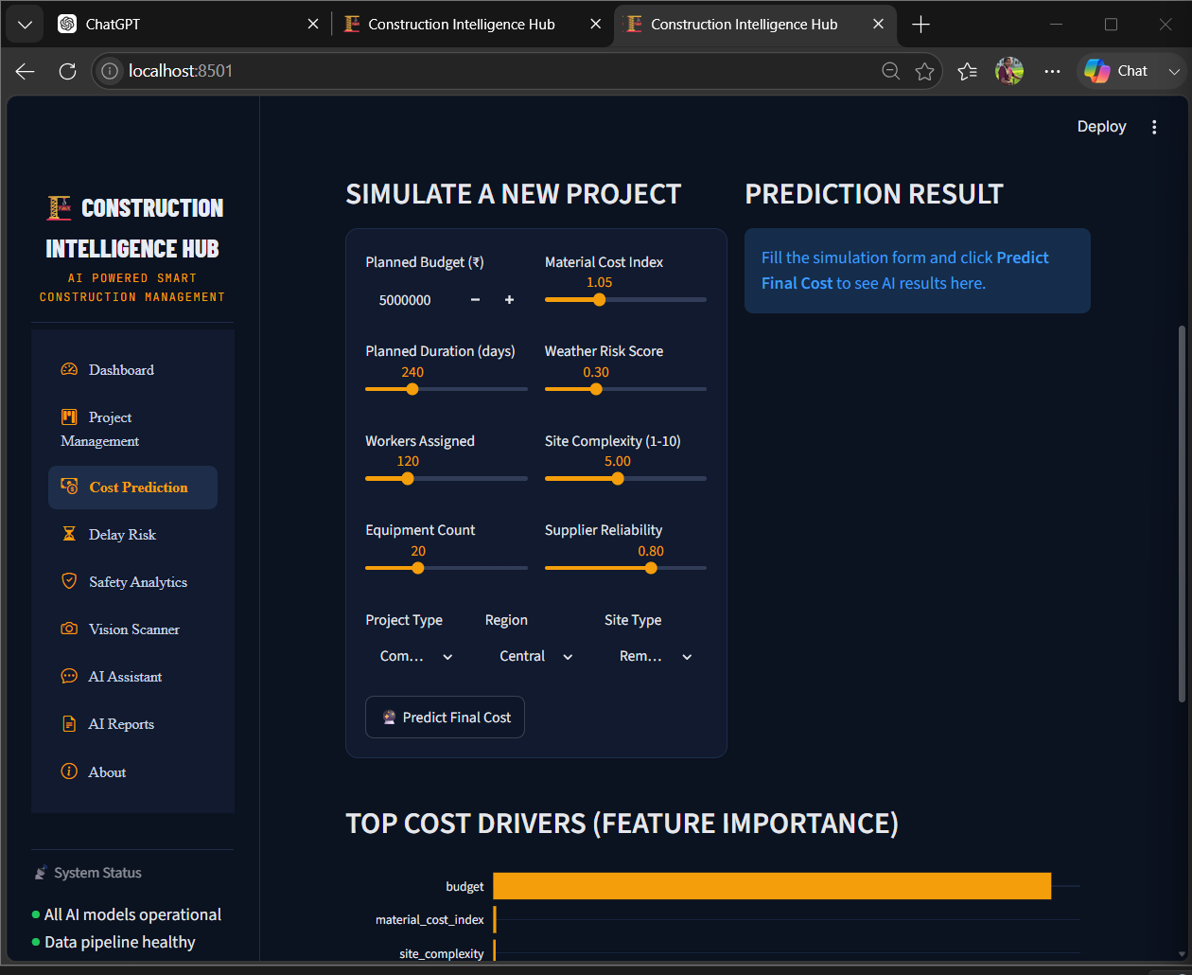

Figure 8.3 – Cost Prediction
Definition: The Cost Prediction page forecasts a project's final cost from a set of planning inputs.
Explanation: The page displays model accuracy figures at the top, followed by a “Simulate a New Project” form where the user enters Planned Budget, Material Cost Index, Planned Duration, Weather Risk Score, Workers Assigned, Site Complexity, Equipment Count, Supplier Reliability, Project Type, Region, and Site Type.
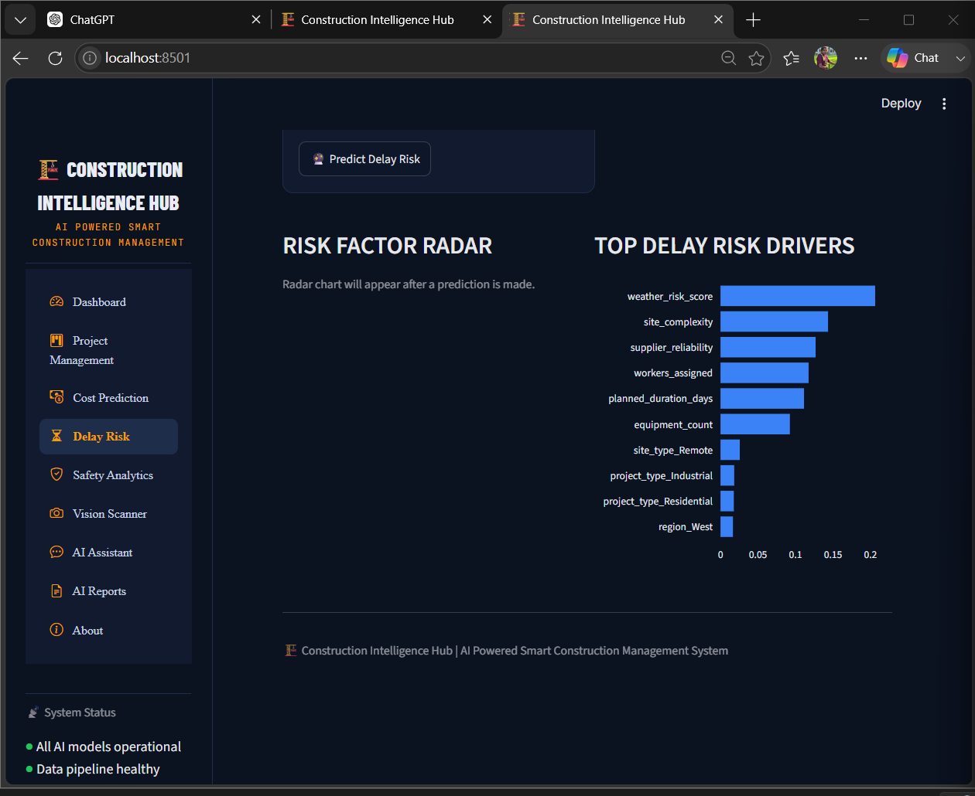

Figure 8.4 – Delay Risk

Definition: The Delay Risk page assesses the likelihood that a project's schedule will slip.
Explanation: After the user fills in a project's Planned Duration, Weather Risk Score, Site Complexity, Supplier Reliability, Workers Assigned, and Equipment Count and clicks Predict Delay Risk, the page shows the predicted risk level along with a radar chart of risk factors and a ranked list of the top delay-risk drivers for the portfolio.
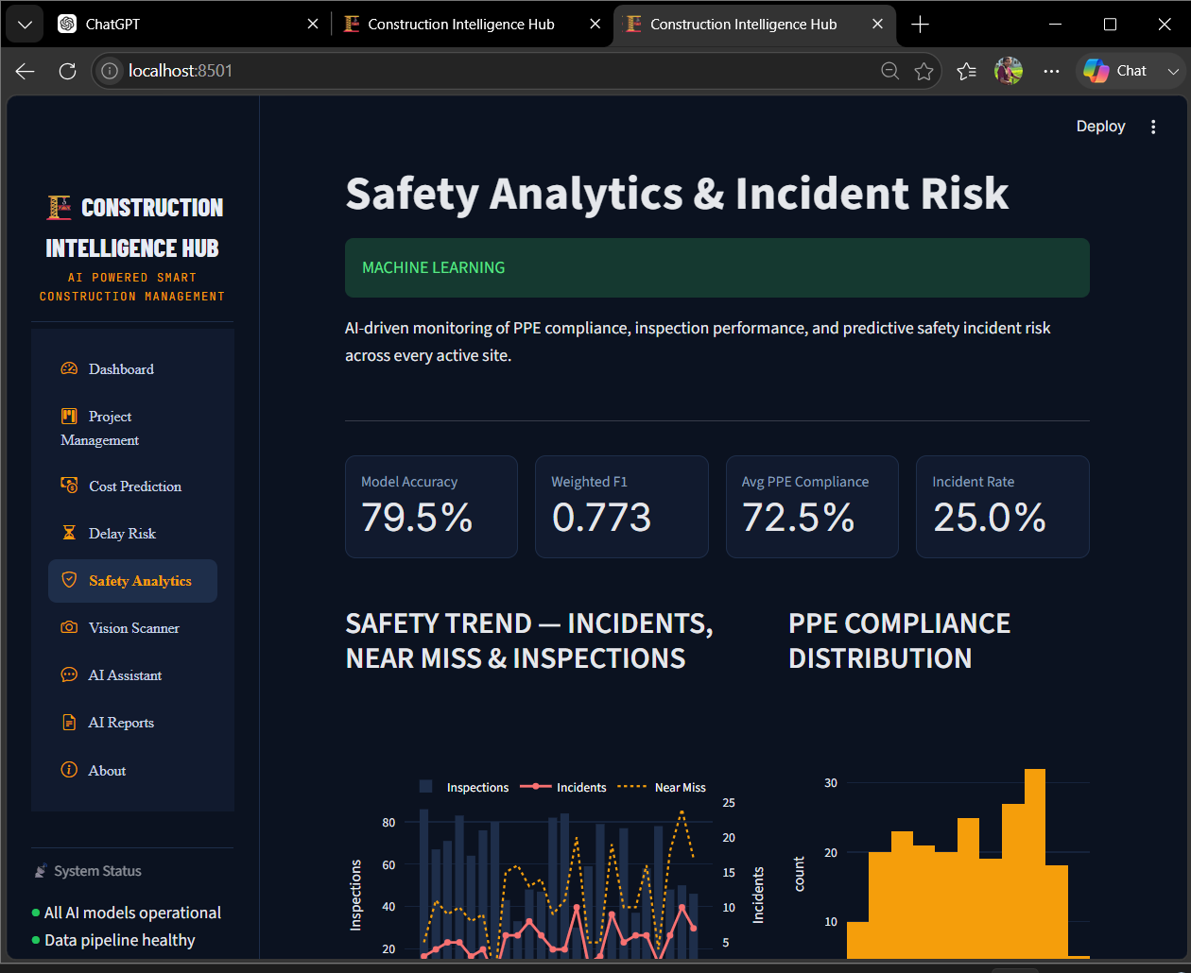
Figure 8.5 – Safety Analytics
Definition: The Safety Analytics page monitors site safety performance and incident risk.
Explanation: Summary cards show overall model accuracy, average PPE compliance, and the incident rate across the portfolio. A trend chart plots Inspections, Incidents, and Near Misses over time, and a histogram shows how PPE compliance scores are distributed across sites.

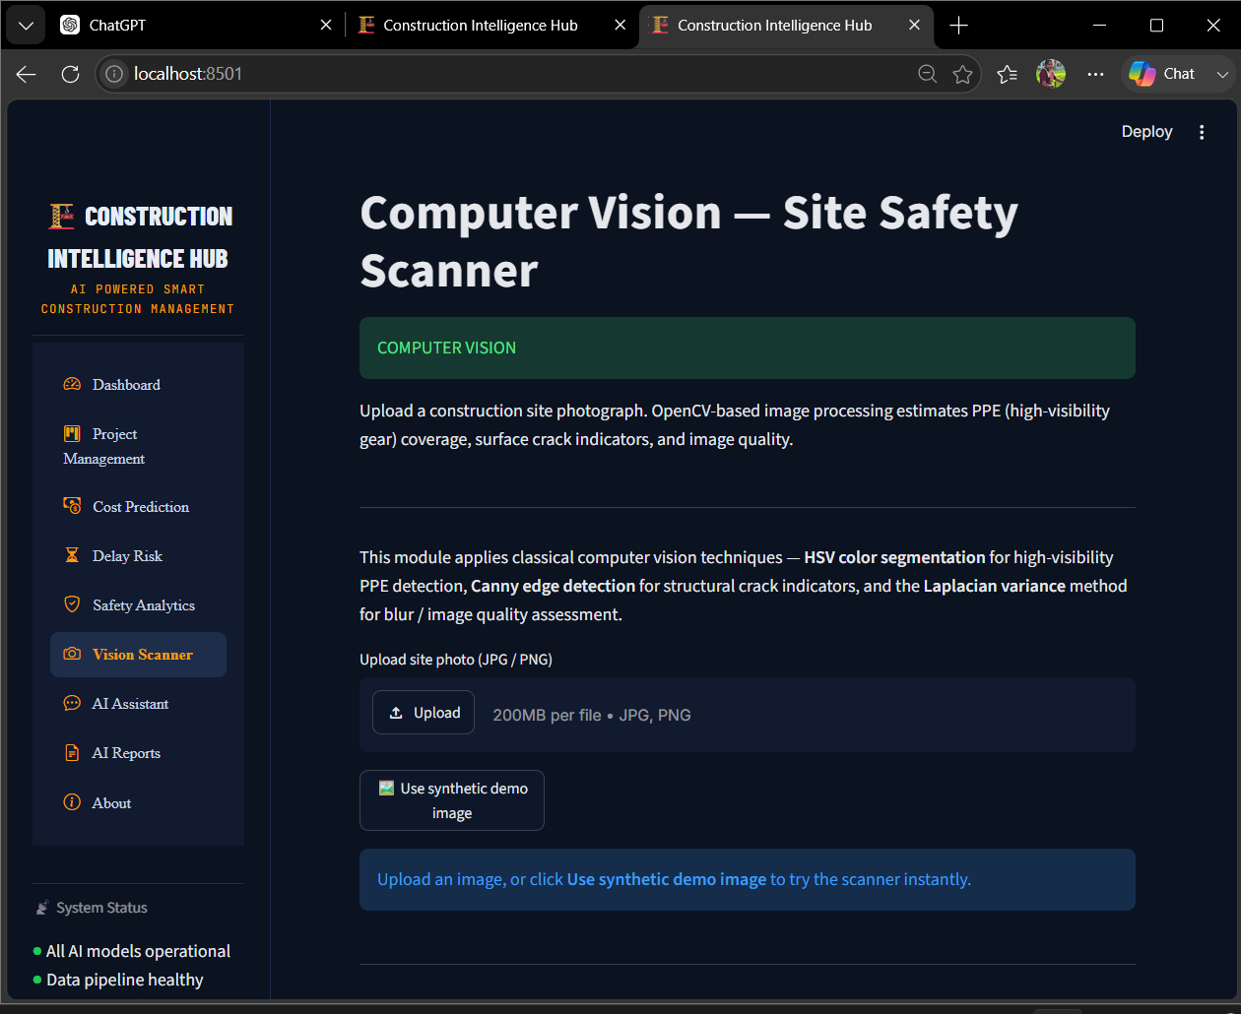

Figure 8.6 – Vision Scanner

Definition: The Vision Scanner lets a user upload a construction-site photo for automated visual analysis.
Explanation: The page explains that it estimates PPE (high-visibility gear) coverage, surface crack indicators, and overall image quality from an uploaded JPG/PNG photo. A “Use synthetic demo image” option lets the user try the scanner instantly without uploading their own photo.
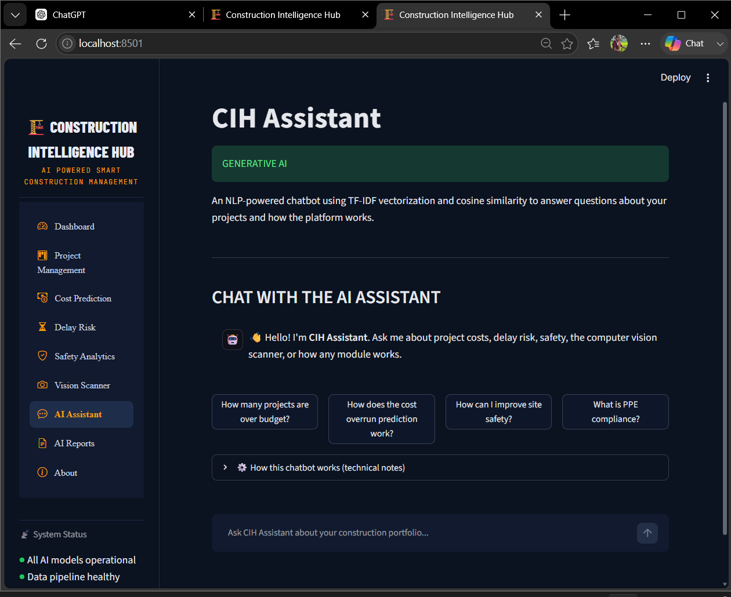
Figure 8.7 – AI Assistant
Definition: The AI Assistant is a chatbot that answers questions about the project portfolio and about how the platform works.
Explanation: The assistant greets the user and offers example questions as quick-reply buttons, such as “How many projects are over budget?” and “What is PPE compliance?” A text box at the bottom lets the user type any question about the portfolio, and an expandable panel explains how the chatbot works.

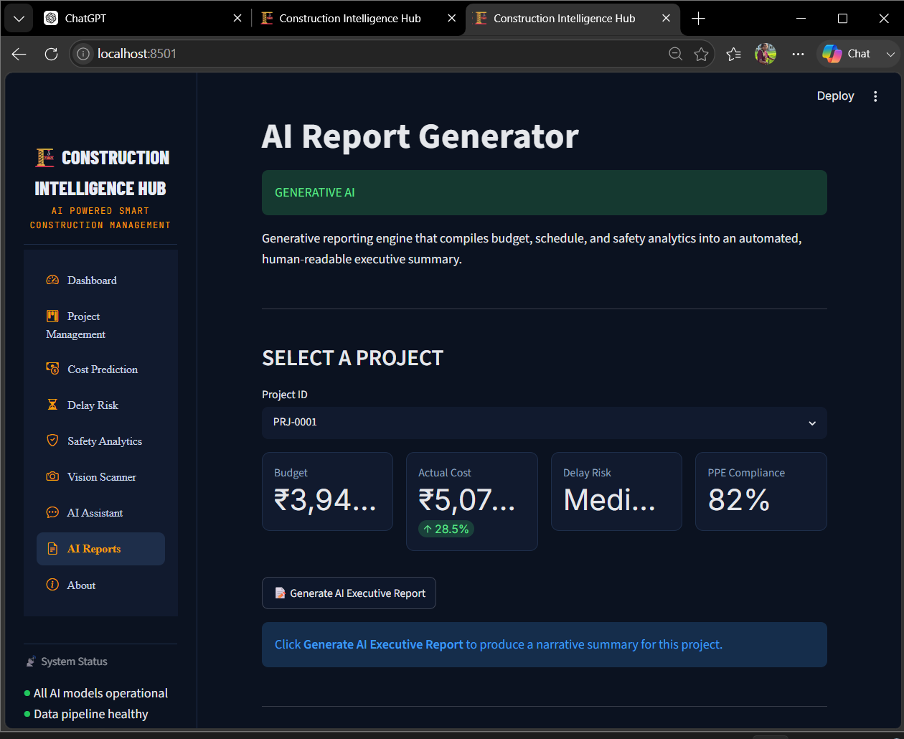
Figure 8.8 – AI Reports

Definition: The AI Reports page compiles a single project's data into an automated executive summary.
Explanation: The user selects a Project ID from a dropdown, and the page displays that project's Budget, Actual Cost, Delay Risk, and PPE Compliance as quick-reference cards. Clicking “Generate AI Executive Report” produces a written narrative summary of the project's status.
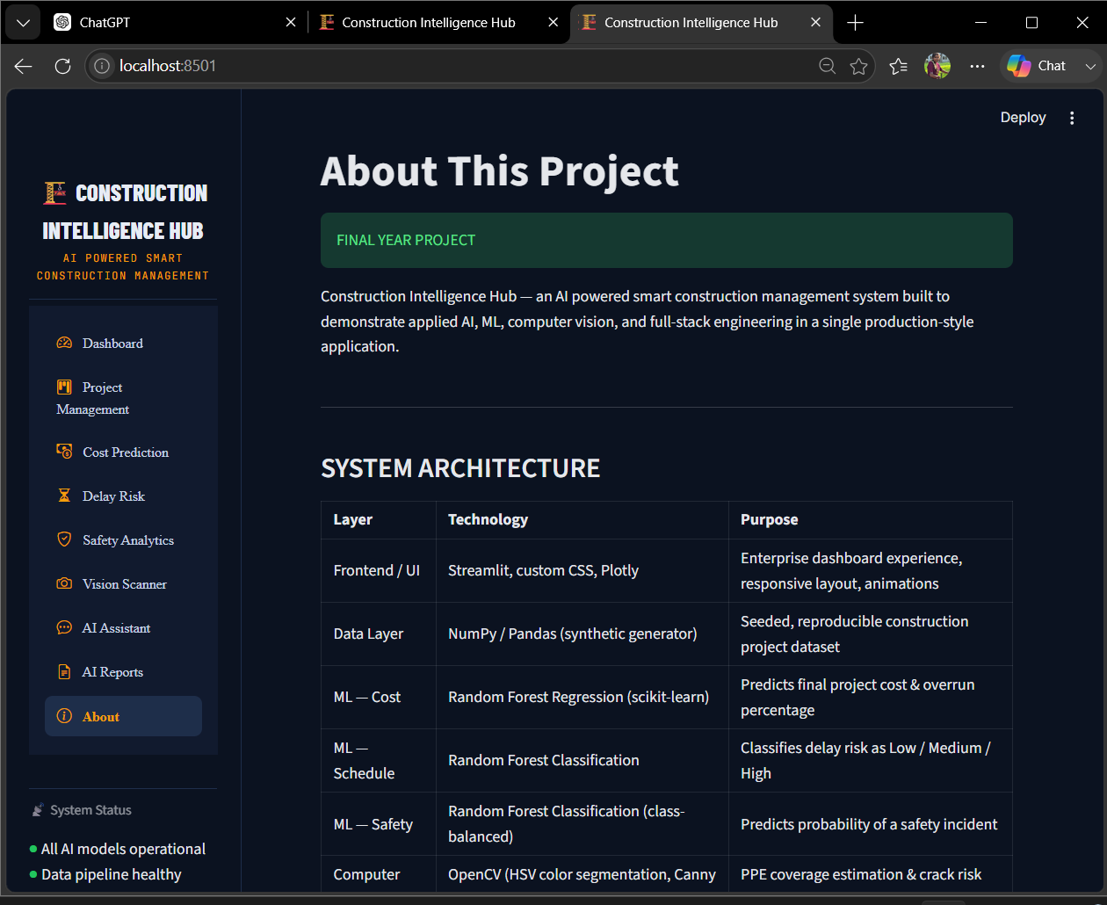

Figure 8.9 – About This Project

Definition: The About page describes the overall system architecture and the technologies used to build the application.
Explanation: A table lists each layer of the system – Frontend/UI, Data Layer, Cost Prediction, Delay Risk, Safety Analytics, Computer Vision, and Generative AI – together with the technology used for each and its purpose, followed by a summary of the key capabilities demonstrated and a disclaimer that the data shown is generated for demonstration purposes.

9. Module Description
The application is organized into the following modules:

Module | Description
Dashboard | Shows a real-time, portfolio-wide summary with metric cards and charts.
Project Management | Provides filterable project tracking with a timeline (Gantt) view and a project registry.
Cost Prediction | Forecasts a project's final cost from planning inputs such as budget, duration, and site complexity.
Delay Risk | Assesses the likelihood of schedule slippage for a project based on its risk factors.
Safety Analytics | Monitors PPE compliance, inspection trends, and predicts safety-incident risk.
Vision Scanner | Analyzes an uploaded site photo to estimate PPE coverage, crack indicators, and image quality.
AI Assistant | A chatbot that answers questions about the project portfolio and the platform.
AI Reports | Generates an automated executive summary for a selected project.
About | Describes the system architecture, technologies used, and key capabilities.

9.1 Dashboard
The Dashboard is the landing page of the application. It provides a real-time overview of the entire project portfolio through metric cards (Total Projects, Active Sites, On-Time percentage, Portfolio Value, Safety Score) and charts comparing budget vs. actual cost and project status distribution.

9.2 Project Management
This section allows users to filter projects by Region, Project Type, and Status, view a Gantt-style timeline of project schedules, and browse a searchable registry of all projects with their key details.

9.3 Cost Prediction
Users can enter planning details for a new or existing project (budget, duration, workers, site complexity, and related factors) to receive an estimated final cost, along with a breakdown of the factors that most influence the estimate.

9.4 Delay Risk
This section allows users to enter project details and receive an assessment of the project's schedule delay risk, along with the key factors contributing to that risk.

9.5 Safety Analytics
This section tracks PPE compliance and safety inspection trends across the portfolio and allows users to predict the incident risk for a specific site based on its safety attributes.

9.6 Vision Scanner
This section allows users to upload a construction site photograph (or use a demo image) to receive an automated assessment of PPE coverage, crack indicators, and image quality.

9.7 AI Assistant
This section provides a chatbot interface where users can ask questions about the project portfolio or about how the platform's modules work, and receive relevant answers.

9.8 AI Reports
This section lets users select a project and generate an automated, human-readable executive summary covering its budget, schedule, and safety status.

9.9 About
This section describes the overall system architecture, the technologies used to build the application, and the key capabilities it demonstrates.

10. Future Enhancements
The following features are planned for future milestones:
- AI-based project delay prediction
- Material demand forecasting
- Equipment monitoring
- Live weather integration
- Worker attendance tracking
- Cost estimation
- Interactive dashboards
- Report generation
- Database connectivity
- Login system

11. Conclusion
Construction Intelligence Hub provides an easy and efficient way to manage construction projects. This milestone focuses on creating a user-friendly interface using Python and Streamlit, while future milestones will add database connectivity, analytics, and AI-based decision support to build a complete, production-ready project management solution.

12. REFERENCES
- Streamlit Documentation – https://docs.streamlit.io
- Python Software Foundation – https://www.python.org
- GitHub Documentation – https://docs.github.com

